Control LED with Your IPhone and Arduino-Bluetooth module SC-HC-08.

Connect the RXD & TXD pins after uploading the code!

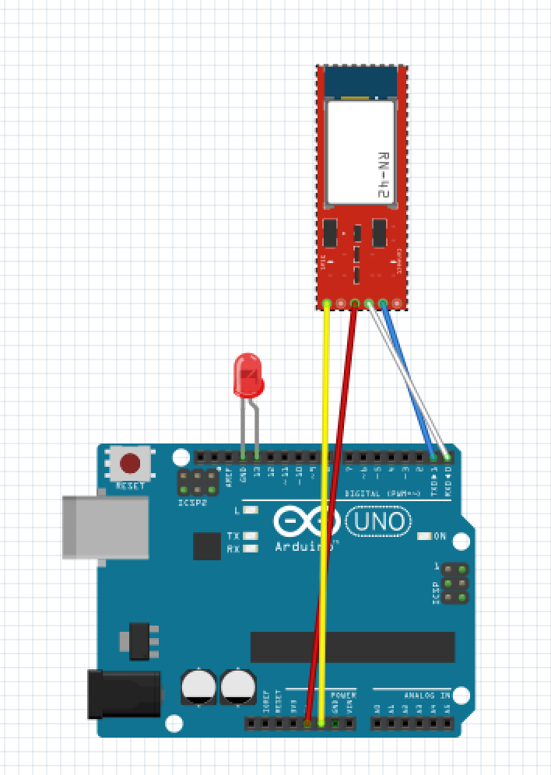

You already know what we are gonna do today…so lets get started !

Things you’ll need :-

* Arduino board
* Breadboard
* Bluetooth module/sensor – HC08
* Couple of jumpers/single stranded wires
* LEDs
* An IPhone obviously  )

Connections Of Bluetooth module HC08 :-

VCC – to VCC of Arduino.  
GND – to GND of Arduino.  
RX – to digital pin 0(TX pin) of Arduino.  
TX – to digital pin 1(RX pin) of Arduino. (connect RX & TX pin after uploading the code)

*Of LED –*  
Positive terminal – to pin 13 of Arduino.  
Negative terminal – GND of Arduino.

The arduino code as follows:

//bluetooth example

// SH-HC-08 bluetooth model, characteristic : FFE1, ios apps dsd tech,bluetoothLE, LightBlue LE

// Send H (in hex 48) to turn light on, any other to turn off

int ledpin = 13; //led in pin 13,and gnd

char val; // variable to receive data from the serial port

void setup() {

pinMode(ledpin, OUTPUT);

digitalWrite(ledpin, LOW);

Serial.begin(9600); // Default connection rate for my BT module

}

void loop() {

if( Serial.available() ) // if data is available to read

{

val = Serial.read(); // read it and store it in 'val'

}

if( val == 'H' ) // if 'H' was received

{

digitalWrite(ledpin, HIGH); // turn ON the LED

Serial.write("on");

} else {

digitalWrite(ledpin, LOW); // otherwise turn it OFF

Serial.write("off");

}

delay(100); // wait 100ms for next reading

}

Procedure :-

1. Make the connections as shown in the above image. Don’t connect the RX & TX pins WHILE/BEFORE  uploading the code !
2. Copy the code and upload.
3. You can use the following apps from the App store

(LightBlue LE, DSD technologies, or BluetooothLE) or the app in this project (BLEDemo)

1. Scan and connect to SC-HC-08, select characteristic FFE1.
2. To turn on the LED by sending ascii H (46 in Hex) or any other char to turn off

BLEDemo project

